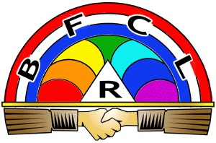
International Order of the Rainbow for Girls
An International Service Organization for Girls ages 11-20
Founded in 1922
Make a difference in the world while having fun!

Provide volunteer opportunities
Take you to fun activities, theme parks, and more
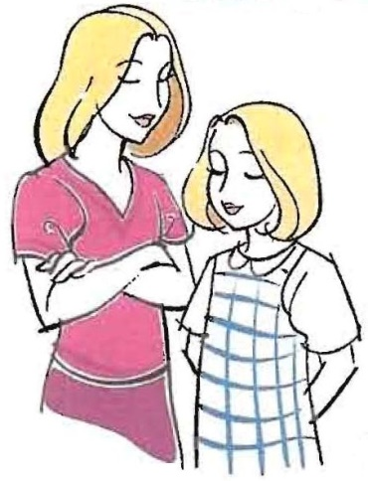
Give you lifelong “sisters” who accept you for who you are
Help you become a confident leader
Provide a safe and rewarding environment
Provide opportunities to earn money for college
Connect you with positive mentors & “big sisters”
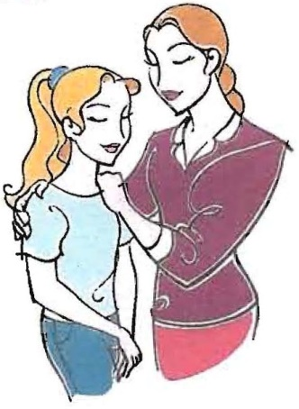
Teach public speaking & time management
Give guidance through your teen years
Travel the state, country, even the world!

Learn, Share, and Grow with Us!
We welcome girls between the ages of 11 and 20
Membership is open to any race or religious background

Membership is now open – contact for more details
[name]
[email]
[name]
[email]

Neither sponsored nor endorsed by the school or the district.
Non-Profit 501(c)3 Organization

