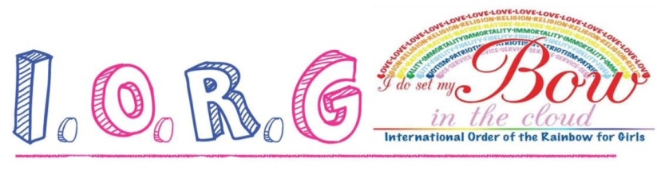
Colorado Rainbow Gets Girls Ready For Life
The International Order of the Rainbow for Girls is an organization for girls ages 11-20 that provides leadership experience while encouraging girls to give back to their community.
- Looks good on job and college Applications
- Scholarship opportunities
- Lifelong friendships
- Make a difference in your community

iorgcolorado.org
Contact:
Email:
Contact:
Email:
Contact:
Email:
Contact:
Email:
Contact
Email:
Contact:
Email:
Contact:
Email:
Contact:
Email:
Contact:
Email:
Contact:
Email:
Contact:
Email:

