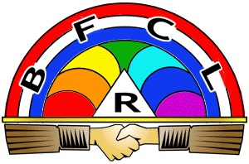
International Order of the Rainbow for Girls
An International Service Organization for Girls ages 11-20
Founded in 1922
Make a difference in the world while having fun!
Colorado Rainbow Gets Girls Ready for Life

The International Order of the Rainbow for Girls is an organization for girls ages 11-20 that provides leadership experience while encouraging girls to give back to their community.

- Looks good on job and college Applications
- Scholarship opportunities
- Lifelong friendships
- Make a difference in your community

iorgcolorado.org
Contact:
Email;
Contact:
Email;
Contact:
Email;
Contact
Email;
Contact:
Email;
Contact:
Email;
Contact:
Email;
Contact:
Email;
Contact:
Email;
Contact:
Email;

